Induced Characters, Representations and the Froebenius Reciprocity Theorem

Introduction

For the majority of chapters 1 and 2, I found the original material in Ledermann’s book Introduction to Group Characters. However, the notation and approach used differed from that of the course and so I adapted it to fit. Here, I have assumed all topics, definitions and theorems covered by the Group Representation Theory course and so introduce any additional topic accordingly. I have used Chapter 1 to introduce the definition of an induced representation and to lay down some ground work for the second chapter where we prove the Froebenius Reciprocity Theorem itself. The third chapter will then discuss applications of the Reciprocity Theorem and further topics.

Chapter 1: Induced Representations

Let H be a subgroup of a group G with ⎟G:H⎜=n. Suppose that ρ:G→Gl_{q}(C) is a representation of H. We extend ρ to the whole of G by putting ρ(x) = 0 ∀x∈G with x∉H. Let {t₁, …, t_{n}) be a right transversal of H in G. Then G=Ht₁ ∪ … ∪ Ht_{n}. For every x∈G, we define a matrix σ(x) of degree qn, arranged as an n × n array of blocks, each of degree q by setting the (i,j)-th place to be ρ(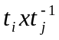). So the matrix will look as follows:

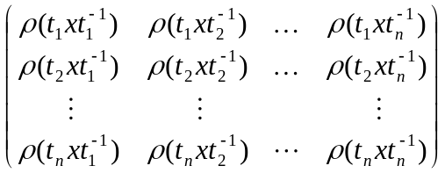.

Proposition 1.1: σ is a representation of G.

Proof: It suffices to show that σ is a homomorphism.

Comparing the (i,j)-th block on both sides, we see that σ(x)σ(y) = σ(xy) is equivalent to the assertion that for all fixed i, j, x and y,

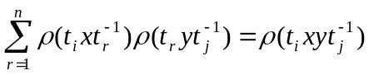.(∗)

There are two cases to consider depending on the nature of the right hand side of this equation.

i) 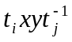∉H
Hence, by the above discussion, the right hand side is the zero matrix. For each r, 1 ≤r≤ n, either 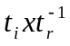∉H or 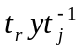∉H, otherwise we would have that ()() = 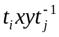∈H contradicting our present hypothesis. Hence, each term on the left hand side of our equation (∗) is zero and the two sides agree.

ii) ∈H
Let = v. The element t_{i}x belongs to exactly one coset say t_{i}x∈Ht_{s} so that u = 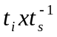∈H. Hence, if r ≠ s, we have that 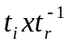∉H. It follows that the sum on the left of (∗) reduces to the case where r = s. That is:

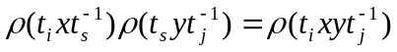.

The term is non-zero as 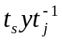= u⁻¹v∈H and (∗) is equivalent to ρ(u)ρ(u⁻¹v) = ρ(v), which is true.

Hence σ is a representation of G.
■

The proposition has shown that, for a fixed value of i, exactly one block in the above matrix is non-zero. Similarly, for a fixed value of j, one and only one block is zero. This happens when i is such that 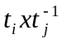∈H ⇒ t_{i}∈Ht_{j}x⁻¹. Hence, σ(x) can be described as a permutation matrix, the units in such a matrix having been replaced by the blocks ρ.

Definition 1.2: The representation σ(x) of G, constructed in the above way is said to have been induced by the representation ρ(u) of H.

Let φ(u) be the character of ρ(u). We define φ(x) = 0 if x∉H to keep in line with the above.

Definition 1.3: The character of σ(u) is called the induced character of φ and is denoted by φ^{G}. Hence, φ^{G}(x) =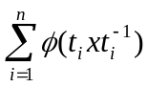.

In proposition 1.1, we made a choice of transversal. We need to show the definition of the induced character above is well defined. That is to say that is unaffected by an alternative choice of transversal. We shall show this in the lemma 1.5. But first, we need to prove the following result:

Lemma 1.4: If x,y∈G are conjugate, then φ(x) = φ(y).

Proof: Let x,y∈G be conjugate. Then, ∃t∈G such that y = t⁻¹xt. Let ρ be a representation of G. Then, ρ(y) = ρ(t⁻¹xt) = ρ(t)⁻¹ρ(x)ρ(t) (since ρ is a homomorphism).
Then, det(λI-ρ(y)) = det(ρ(t)⁻¹)det(λI-ρ(x))det(ρ(t)) = det(λI-ρ(x)). By, comparing coefficients of λ^{m-1} we find that ρ(y)₁₁ + ρ(y)₂₂ + … + ρ(y)_{nn} = ρ(x)₁₁ + ρ(x)₂₂ + …+ ρ(x)_{nn}, that is that φ(y) = φ(x).
■

Lemma 1.5: φ^{G}(x) is unaffected by an alternative choice of transversal for H in G.

Proof: Let s₁, …, s_{n} be a different choice of transversal to the one in proposition 1.1. Then, ∃ u₁, …, u_{n}∈H such that s_{i} = u_{i}t_{i} , 1 ≤ i ≤ n. Hence, 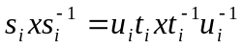.
If 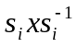∈H so does 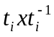 and, since these elements are conjugate in H, 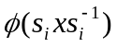=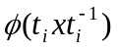, by lemma 1.4.
If ∉H, neither does and hence = 0 =.
By summing over all i, we find that φ^{G}(x) =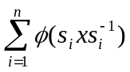, as required.
■

We will now look at alternative ways of writing the formula for the induced character. Let u∈H be arbitrary and choose the transversal s_{i} = ut_{i} 1 ≤ i ≤ n. Then,
φ^{G}(x) =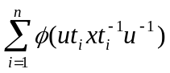. Summing over u in H, we note that the left hand side is multiplied by ⎟H⎜, whilst the products ut_{i} run over G exactly once. Hence,
φ^{G}(x) =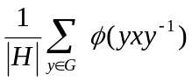. (1.6)
Chapter 2: The Froebenius Reciprocity Theorem

Definition 2.1: Let φ, ψ : G → C be two functions. We define their inner product
< φ, ψ >_{G} to be < φ, ψ >_{G} = 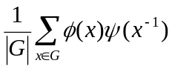.

Note: If φ is a character of G then 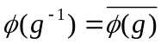 ∀g∈G. We will write 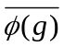 as 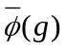 for short. Hence, the above equation can be rewritten as:

< φ, ψ >_{G} = 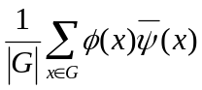.

Definition 2.2: Let ρ be a representation of G. Then ρ|_{H} is the restriction of ρ to H and this is a representation of H. If φ is the character of ρ, then we denote the restricted character by φ_{H}. So φ_{H}(u) = φ(u) ∀u∈H.

Definition 2.3: Let G be a group. θ: G→ C is said to be a class function if θ(gxg⁻¹) = θ(x) ∀ x,g∈G. All characters are class functions.

Theorem 2.4: Froebenius Reciprocity

Let H be a subgroup of G. If ψ and φ are characters of H and G respectively then,

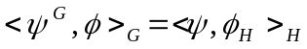.

Proof: Applying (1.6) to ψ we have that

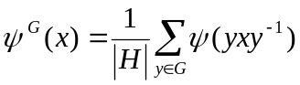,

where ψ(z)=0 is zH. Then,

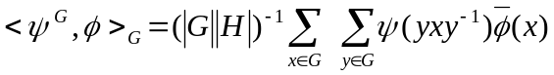
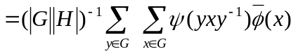

For fixed y, let z=yxy⁻¹, that is x= y⁻¹zy. As x runs through G, so does z. Hence, we may use z as the summation variable in the inner sum and obtain that

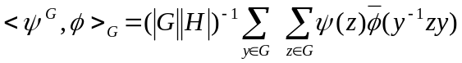.

Since φ is a class function G, we have that φ(y⁻¹zy) = φ(z). The terms are therefore independent of y and the summation with respect to y merely amounts to a multiplication by g. Thus,

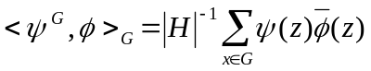.

But ψ vanishes when z does not belong to H. Hence, the summation may be restricted to H and we find that,

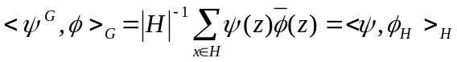,

as required.
■
Chapter 3: Applications of the Froebenius Reciprocity Theorem

Definition 3.1: G is the class of triples (G, z, σ) where G is a finite group, z is an element of order 2 in the centre of G and σ: G→Z/2 is a homomorphism with σ(z)=0. Often, we will denote the elements in G simply by G to make notation less cumbersome.

Definition 3.2: Let ρ be a representation of (G, z, σ). The associate representation ρª is given by ρª(g)=(-1)^{σ(g)}ρ(g). If ρ is equivalent to ρª it is said to be self-associate.

Remark 3.3: The character θª of the associate ρª agrees with the character θ of ρ on ker σ and takes the value –θ(g) if g∈G \ ker σ. It follows that a representation ρ is self-associate ⇔ θ is zero on G \ ker σ.

Definition 3.4: Let NG, g∈G and ρ be a representation of N. Then the conjugate representation ρ^{g} is defined by ρ^{g}(x) = ρ(gxg⁻¹), ∀x∈N.

Remark 3.5: Let ρ be a representation of N, where NG. Let g∈G and x,h∈N. Then:

ρ(hgxg⁻¹h⁻¹) = ρ(h)ρ(gxg⁻¹)ρ(h)⁻¹.

Hence, ρ^{g} is equivalent to ρ^{hg} and, in particular, ρ^{h} is equivalent to ρ ∀h∈N. It follows that for (G, z, σ)∈G and ρ a representation of ker σ, there are either one or two equivalence classes of representations conjugate to ρ. For g∈ker σ, ρ^{g} is unique up to equivalence independently of g and we shall denote it ρ^{c} and its character φ^{c}, where φ is the character of ρ. Thus ρ is self-conjugate ⇔ φ^{c} = φ.

Definition 3.6: If χ is a character and χ = χ₁ + … + χ_{n} then we say that χ₁, …,χn are constituents of χ.

Theorem 3.7: Let G∈G and suppose that the kernel of σ, G₀ is a proper subgroup of G. Let ρ be an irreducible representation of G. If R is self-associate, then ρ|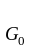has two non-equivalent irreducible constituents that are conjugate to each other. If ρ is not self-associate, then ρ|is irreducible, self-conjugate and is equivalent to ρª|.

Proof: Suppose firstly that ρ is self-associate and let θ be its character. It follows by remark 3.3 that θ vanishes off G₀. As θ is the character of an irreducible representation, we have:

2 = 2<θ, θ>
= 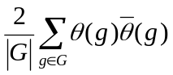
= 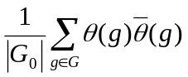
= 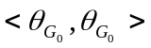

Since 1²+1² is the only decomposition of 2 as the sum of squares, 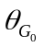is a sum φ+ψ say, of two inequivalent irreducible characters of G₀.

By the Froebenius Reciprocity Theorem (2.4), 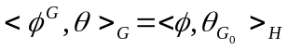 = 1.
Thus, φ^{G} = θ + ζ for some character ζ, possibly zero. Similarly, ψ^{G} = θ + η for some character η. But then,

2θ(1) + ζ(1) + η(1) = φ^{G}(1) + ψ^{G}(1)
= 2φ(1) + 2ψ(1)
= 2(1)
= 2θ(1).

Thus, ζ = 0 = η since the dimensions ζ(1) and η(1) of the corresponding representations are zero. Now for any g∈ker σ

(g) = θ(g) = φ^{G}(g) = φ(g) + φ^{c}(g)

by the definition of induced characters and by remark 3.5. Thus,= φ(g) + φ^{c}(g) and so ψ = φ^{c}, as required.

On the other hand, suppose that θ is the character of an irreducible representation of G what is not self-associate. Let φ be any irreducible constituent of . Then for some character α, possibly zero, we have:

= φ + α = 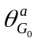.

By the Froebenius Reciprocity Theorem (2.4), ≥ 1. Similarly, 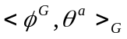≥ 1. Thus, for some character β, we have that φ^{G} = θ + θª + β, since θ and θª are irreducible and inequivalent. Then:

2φ(1) = φ^{G}(1) = θ(1) + θª(1) + β(1) = 2φ(1) + 2α(1) +β(1).

Thus, α(1) = β(1) = 0, so α and β are zero giving:

= φ = .

Finally, for g∈G₀ and g₁∈G\G₀,

,

so φ^{c} = φ, as required.
■

Definition 3.8: An irreducible representation ρ of (G, z, σ) is negative if ρ(z) = –I, where I is the identity matrix.

Corollary 3.9: Let (G, z, σ) be such that σ is non-zero. Then:
- The number, c, of self-associate irreducible negative representations of G is the same as the number of conjugate pairs of non-self-conjugate irreducible negative representations of ker σ;
- The number, d, of associated pairs of non-self-associate irreducible negative representations of G equals the number of self-conjugate irreducible negative representations of ker σ.

Note: In the above, by the number of representations we mean the number of representations up to equivalence.

Proof: We may confine our attention to negative representations since:
- the restriction of a negative representation of G to G₀ = ker σ is negative;
- inducing a negative representation of G₀ gives a negative representation of G.

- The first part of 3.7 gives a map from the set of self-associate irreducibles θ to the relevant set of conjugate pairs {φ, φ^{c}}, determined by = φ + φ^{c}. The equation φ^{G} = θ in its proof shows that this map is injective. To prove surjectivity, let {φ, φ^{c}} be a conjugate pair. We shall find an irreducible θ with = φ + φ^{c}; the second part of 3.7 guarantees that θ is self-associate.

Let θ be any irreducible constituent of φ^{G} (= (φ^{c})^{G}). By The Froebenius Reciprocity Theorem (2.4):

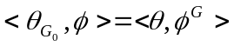≥ 1.

Similarly, 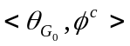≥ 1. Thus, = φ + φ^{c} + α, for some character α, possibly zero. Now, 2φ(1) = φ^{G}(1) ≥ θ(1) = (1) = 2φ(1) + α(1). Hence, α(1) = 0, so α = 0, as required.

- Similarly, the second part of 3.7 gives an injective map from the relevant set of pairs {θ, θª} to the set of self-conjugate negative irreducibles φ of G₀. Given such a φ, we must find an irreducible character θ for G such that = φ; the first part of 3.7 guarantees that θ will not be self-associate. Now,

<φ^{G}, φ^{G}> =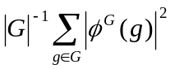
=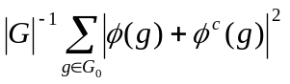
=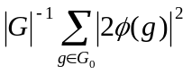
=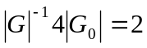

Thus, φ^{G} = θ + γ for a distinct pair of irreducible characters θ and γ of G. Then,

=1.

Thus, = φ + μ for some character μ. Similarly, 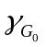= φ + ν for some ν. But then,

2φ(1) = φ^{G}(1) = θ(1) + γ(1) = 2φ(1) + μ(1) + ν(1).

So, μ = ν = 0 and = φ, as required.
■

Definition 3.10: Let Irr(G) be the set of irreducible characters of G.

Proposition 3.11: Irr(G) is an orthonormal basis for the space of complex valued functions on G that are constant on conjugacy classes. Such a class function θ is a character ⇔ <θ, χ> is a non-negative integer ∀χ∈G.

Proof: Let s be the dimension of the space of complex valued class functions. s = the number of conjugacy classes of G = the dimension of Z(CG). On the other hand, the dimension of Z(CG) = the number of irreducible CG-modules = the number of inequivalent irreducible representations = the number of inequivalent irreducible characters.

Hence, dim(Z(CG)) = ⎟Irr(G)⎜.

Since Irr(G) is an orthonormal set, it is an orthonormal basis for the space of class functions. It follows that any complex valued class function can be expanded as a linear combination:

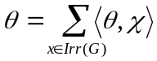

where each summand is a complex number. As the sum of two characters is a character, any non-negative linear integral combination of characters is a character. As any CG-module is the sum of irreducible CG-modules, the converse follows and hence if θ is a character of a module M, then <θ, χ> is the number of irreducible constituents in any direct sum decomposition of M whose trace is χ.
■

Proposition 3.12: Suppose that H ⊆ K ⊆ G are groups and θ is a character on H. Then (θ^{K})^{G} = θ^{G}.

Proof: By 3.11, it suffices to show that <(θ^{K})^{G}, χ> = <θ^{G}, χ> ∀χ∈Irr(G). We use the Froebenius Reciprocity Theorem (2.4):

<(θ^{K})^{G}, χ>_{G} = <θ^{K}, χ_{K}>_{K} = <θ^{H}, χ_{H}>_{H} = <θ^{G}, χ>_{G}.
■

Proposition 3.13: Suppose that θ is a class function on H ⊆ G and ψ is a class function on G. Then:

θ^{G}ψ = (θψ_{H})^{G}.

Proof: Let g∈G, then:

(θ^{G}ψ)(g) =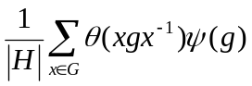
=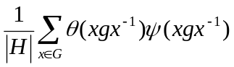
=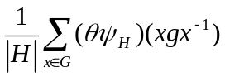
= (θψ_{H})^{G}.
■

Definition 3.14: The stabilizer of θ in G is G_{θ} = {g∈G⏐θ^{g} = θ}. If θ is a character, it follows that G_{θ} ⊇ H since θ is constant on conjugacy classes.

Theorem 3.15 (Clifford):

Suppose that H G, χ∈Irr(G) and θ is an irreducible constituent of χ_{H}. Then there exists one and only one irreducible character ψ of G_{θ} that satisfies both of the following conditions:

- <ψ^{G}, χ> ≠ 0;
- <ψ_{H}, θ> ≠ 0.

Furthermore, ψ^{G} = χ, ψ_{H} = eθ for some positive integer e and if {x₁, …, x_{t}} is a set of coset representatives for G_{θ} in G, then:

χ_{H} = 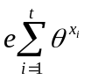.

Proof: Let θ∈Irr(H) and choose coset representatives {x₁, …, x_{t}} for G_{θ} in G. From the definition of induced characters, we easily get:

(θ^{G})_{H} =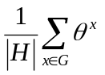
=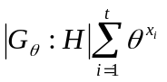.

Now let χ∈Irr(G) and choose θ to be an irreducible constituent of χ_{H}. By the Froebenius Reciprocity Theorem (2.4), χ is a constituent of (θ^{G})_{H}. Since all irreducible constituents of (θ^{G})_{H} are conjugate in G by the above calculation, the same is true for χ_{H}. Moreover, since χ_{H} is a G-invariant character, it follows that each of those irreducible constituents occurs with the same multiplicity. Thus we can write:

χ_{H} = for some positive integer e. (3.16)

Because θ is an irreducible constituent of χ_{H} and H ⊆ G_{θ} ⊆ G, it follows that there exists an irreducible constituent ψ of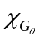such that θ is an irreducible constituent of ψ_{H}. Note that ψ satisfies both conditions a) and b) of the theorem. We can apply (3.16) with ψ in place of χ to get:

ψ_{H} = e₁θ (3.17)

for some positive integer e₁. Indeed we can write:

= aψ + φ (3.18)

where a > 0 and <ψ, φ> = 0. Then, χ_{H} = aψ_{H} + φ_{H} = ae₁θ + φ_{H} from which it follows that:

ae₁ ≤ <χ_{H}, θ> = e. (3.19)

Applying the reciprocity theorem to (3.18) we get that ψ^{G} = aχ + μ, where <χ, μ> = 0. By definition of induced characters:

tψ(1) = ψ^{G} = aχ(1) + μ(1) ≥ aχ(1) (3.20)

From (3.16) we get χ(1) = etθ(1); from (3.17) we get that ψ(1) = e₁θ(1). Substituting this into (3.20), we get:

te₁θ(1) ≥ aetθ(1)
⇒ e₁ ≥ ae.

(3.9) implies that e = e₁, a = 1 and that (3.20) is equality. This is possible only when μ(1) = 0 ⇒ μ = 0. Therefore, ψ^{G} = χ and ψ_{H} = eθ. Now, (3.16) and (3.18) imply that θ is not a constituent of φ_{H} and hence ψ is the unique irreducible character of G_{θ} that satisfies conditions a) and b) of the theorem.
■

Bibliography

Group Representation Theory lecture notes

Walter Ledermann: Introduction to Group Characters
Cambridge University Press 1977

William Fulton and Joe Harris: Representation Theory
Springer-Verlag 1991

P.N. Hoffmann and J.G. Humphreys: Projective Representations of the Symmetric Groups
Oxford Science Publications 1992

David M. Goldschmidt: Lectures on Character Theory
Publish or Perish Inc. 1980

Adapted from W. Ledermann: Introduction to Group Characters p.9 and 10
Group Representation Theory proposition 7.6 iii)
Group Representation Theory proposition 7.5 ii)
W. Ledermann: Introduction to Group Characters p.74
P.N. Hoffmann and J.G. Humphreys: Projective Representations of the Symmetric Groups p.37
Group Representation Theory proposition 7.5 i) and corollary 8.5
Group Representation Theory theorem 8.2
P.N. Hoffmann and J.G. Humphreys: Projective Representations of the Symmetric Groups p.39
Group Representation Theory proposition 6.11
Group Representation Theory proposition 6.5
Group Representation Theory summary of Chapter 6
Group Representation Theory proposition 7.5 i) and corollary 8.5
Group Representation Theory theorem 8.14
D.M. Goldschmidt: Lectures on Character Theory p.3-5

